**Code:**

import pandas as pd

import numpy as np

import seaborn as sns

import matplotlib.pyplot as plt

colnames=['areas','rooms','prices']

dataset = pd.read_csv("https://raw.githubusercontent.com/nishithkotak/machine-learning/refs/heads/master/ex1data2.txt",names=colnames)

dataset.describe()

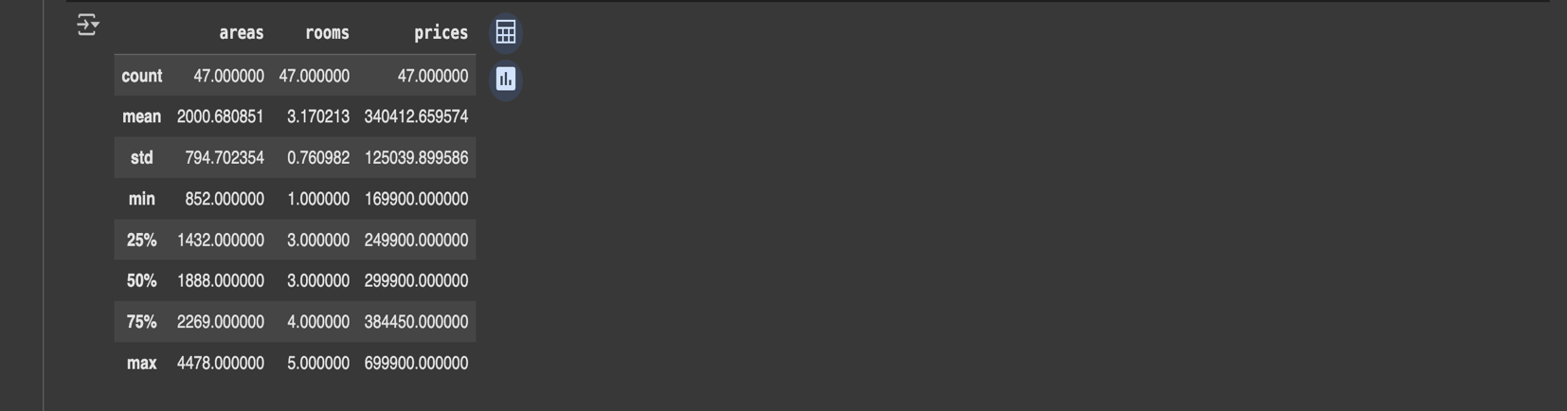

areas=dataset.iloc[0:dataset.shape[0],0:1]

romms=dataset.iloc[0:dataset.shape[0],1:2]

prices=dataset.iloc[0:dataset.shape[0],2:3]

dataset.shape



from posixpath import splitdrive

#function normalization

def feature_normalization(x):

mean=np.mean(x,axis=0)

std=np.std(x,axis=0)

x_normalized=(x-mean)/std

return x_normalized,mean,std

data_norm = dataset.values

m = data_norm.shape[0]

#taking features vectors

x2 = data_norm[:, 0:2].reshape(m, 2)

x2_norm, mean, std = feature_normalization(x2)

y2 = data_norm[:, 2:3].reshape(m, 1)

x2_norm

theta_array=np.zeros((3,1))

def Hypothesis(theta_array , x1 , x2) :

return theta_array[0] + theta_array[1]*x1 + theta_array[2]*x2

def Cost_Function(theta_array,x1,x2,y,m):

total_cost = 0

for i in range(m):

total_cost += (Hypothesis(theta_array,x1[i] , x2[i]) - y[i])**2

return total_cost/(2*m)

def Gradient_Descent(theta_array , x1, x2, y , m ,alpha) :

summation_0 = 0

summation_1 = 0

summation_2 = 0

for i in range(m):

summation_0 += (Hypothesis(theta_array,x1[i] , x2[i]) - y[i])

summation_1 += ((Hypothesis(theta_array,x1[i] , x2[i]) - y[i])*x1[i])

summation_2 += ((Hypothesis(theta_array,x1[i] , x2[i]) - y[i])*x2[i])

new_theta0 = theta_array[0] - (alpha/m)*summation_0

new_theta1 = theta_array[1] - (alpha/m)*summation_1

new_theta2 = theta_array[2] - (alpha/m)*summation_2

new_theta = [new_theta0 , new_theta1 , new_theta2]

return new_theta

def Training(x1, x2, y, alpha, iters):

theta_0 = 0

theta_1 = 0

theta_2 = 0

theta_array = [theta_0, theta_1 ,theta_2]

m = len(x1)

cost_values = []

for i in range(iters):

theta_array = Gradient_Descent(theta_array, x1 ,x2, y, m, alpha)

loss = Cost_Function(theta_array, x1 ,x2, y, m)

cost_values.append(loss)

y_new = theta_array[0] + theta_array[1]*x1 + theta_array[2]*x2

return theta_array , cost_values

def Training(x1, x2, y, alpha, iters):

theta_0 = 0

theta_1 = 0

theta_2 = 0

theta_array = [theta_0, theta_1 ,theta_2]

m = len(x1)

cost_values = []

for i in range(iters):

theta_array = Gradient_Descent(theta_array, x1 ,x2, y, m, alpha)

loss = Cost_Function(theta_array, x1 ,x2, y, m)

cost_values.append(loss)

y_new = theta_array[0] + theta_array[1]*x1 + theta_array[2]*x2

return theta_array , cost_values

alpha = 0.01

iters = 500

area_norm = x2_norm[:, 0]

room_norm = x2_norm[:, 1]

price_norm = y2

theta_array, cost_per_itr = Training(area_norm, room_norm, price_norm, alpha, iters)

predicted_price = theta_array[0] + theta_array[1]*area_norm + theta_array[2]*room_norm

from mpl_toolkits.mplot3d import Axes3D

fig = plt.figure()

ax = fig.add_subplot(111, projection='3d')

ax.scatter(area_norm, room_norm, price_norm, alpha=0.3, c='#FF0000', label="Actual")

ax.plot(area_norm, room_norm, predicted_price, c="#0000FF", label="Predicted")

ax.set_xlabel("Area")

ax.set_ylabel("Rooms")

ax.set_zlabel("Prices")

ax.set_title("Best Fit Line")

plt.legend()

plt.show()

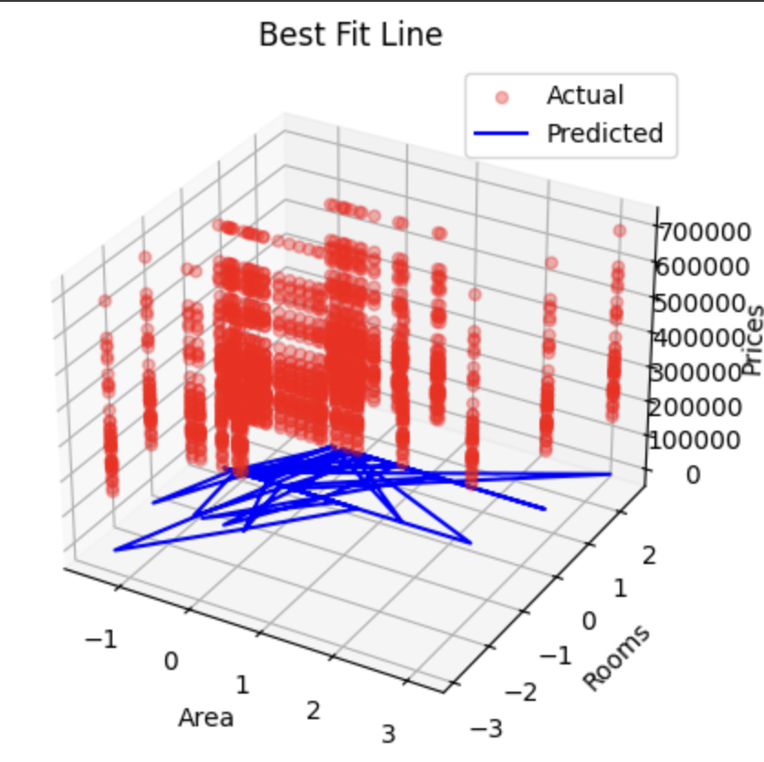

plt.figure(figsize=(8, 6))

plt.subplot(3, 1, 1)

sns.scatterplot(x='areas', y='rooms', data=dataset,palette='prices')

plt.title('Area vs Prices')

plt.xlabel('Area (sq ft)')

plt.ylabel('Prices ($)')

plt.subplot(3, 1, 2)

sns.scatterplot(x='rooms', y='prices', data=dataset, palette='viridis')

plt.title('Rooms vs Prices')

plt.xlabel('Number of Rooms')

plt.ylabel('Prices ($)')

plt.subplot(3, 1, 3)

sns.scatterplot(x='rooms', y='areas', data=dataset, palette='viridis')

plt.title('Rooms vs Area')

plt.xlabel('Number of Rooms')

plt.ylabel('Area (sq ft)')

plt.tight_layout()

plt.show()

